FRENCH CANADIAN CHRISTMAS REVELS

Puget Sound Revels - 2021

OVERTURE

PRIEST:
Once, a long, long time ago in the North Country which is now called Canada, a group of settlers came upon a fertile valley where three rivers flowed together.
(Three blue silk cloths brought out by children)
Papa: “Tiens, This is a good place to build a village.”

Mamman: “Oué!” “What shall we call it?”

Priest: They thought for a bit

Papa: “This name will go on for generations,” , “it has to be dignified.”

Mamman: “Oh, Oué, and it should capture the beauty of the rippling water.”

Children: “Oué! “And it should capture the ambitions that you have for future generations.”

Priest: “Oué!” they agreed. “Difficile, eh?” They thought long and hard.

Papa: “Three rivers. Three rivers. Tiens! How about…….Three Rivers?”

All: “PARFAIT! ”

Priest : they agreed, and they set to work on the first house.

PRIEST:
Years passed and the village grew into a town with a town hall and a church. Every Midsummer they celebrated St. Jean Baptiste with a great bonfire, and every Christmas and New Year they gathered in the town hall to sing and make merry. It was Le Temps des Fêtes….

DANS LE TEMPS DES FÊTES

1. Dans l’temps des fêtes, tout le monde est si gai,

que la toilette est pas trop ménagée.

On va chez son voisin,

On se donne la main,

Et puis on se la souhaite,

Et quand le verre est plain, on fait trinquette.

2. Dans l’temps des fêtes, tout le monde est si gai,

que la toilette est pas trop ménagée.

On va chez son voisin,

On se donne la main,

Et puis on se la souhaite,

Et quand le verre est plain, on fait trinquette.

3. Christmas is here, and joy is in the air,

But sometimes we might forget to comb our hair.

We call upon our friends, we offer them our hands;

And, as the season passes,

we celebrate with them and raise our glasses!

PRIEST

All right, everyone, attention!

(Priest arranges adults, beckons Children to DC. TI-JEAN enters ).

TI-JEAN
I’m here, I’m here! Ready to sing, Mon Pere!

PRIEST:
‘Ti Jean! You’ll be late for your own funeral! Madeleine, pull up your stockings! Mon Dieu! Catherine where is your bonnet? Don’t you know people will be looking at you? (ALBERT moves forward, the worse for wear) Albert, straighten your tie! This is a Christmas party not a poker party.

ALBERT

Oui, oui mon pere, but it is party time so go easy on us eh?

GASTON

Yeah, yeah, we need your spiritual guidance.

PRIEST

Eh?

GASTON

We have a lot of spirits to drink.

Laughter

PRIEST

Attempting to cover the ears of the children

Shhhhh! Gaston, someday your mouth is going to get you into a lot of trouble!

Alors mes enfants - un, deux, trios…..

ANGELS WE HAVE HEARD ON HIGH

All SING (including children)

1. Les anges dans nos campagnes
Ont entonné l’hymne des cieux,
Et l’écho de nos montagnes
Redit ce chant mélodieux:
ADD WOMEN
Gloria in excelsis Deo,
Gloria in excelsis Deo.

CHORUS, BRASS, AUDIENCE and HAND BELLS
2. Angels we have heard oh high,
Sweetly singing o’er the plains.
And the mountains in reply
Echoing their joyous strains:
Gloria in excelsis Deo,
Gloria in excelsis Deo.

3. Shepherds, why this jubilee?
Why your joyful strains prolong?
What the gladsome tidings be
Which inspire your heav’nly song?
Gloria in excelsis Deo,
Gloria in excelsis Deo.

4. Come to Bethlehem and see
Him whose birth the angels sing.
Come adore on bended knee
Christ, the Lord, the newborn King.
Gloria in excelsis Deo,
Gloria in excelsis Deo.

TI-JEAN
Le Raconteur! Le Raconteur est la!

(Le Raconteur enters to greetings from the chorus and the band)

PRIEST
Welcome, Rahoul! So good to see you again. It’s been a long time.

RAHOUL
A year, I think, Mon Pere.

PRIEST
And have you brought us new stories from your travels?

BAND MEMBER
And new tunes?

RAHOUL
I’ve traveled many places since I last was here and I bring you both new stories and new tunes!

PRIEST
Then please……. (He indicates that a stool be set for Rahoul)

RAHOUL – How Raven Brought Daylight, a Story from the First Nations.

Many, many ages ago when the world was still young, Raven and Seagull lived near each other in the far north of Canada. They were very good friends. But in those long-ago times in the north country there was no light except for the stars. Now it so happened that Seagull owned all the daylight which he kept always locked up tight in a box. How he came to own all the daylight of the world….well, that’s another story for another day. But own it he did, and he never let any of it out!

Raven grew jealous of this. “It is not fair that Seagull should keep all the daylight locked up in a box,” he said. “It was meant for all the world and not for him alone.” So he went to Seagull and said, “Give me some of your daylight. You do not need it all and I could use some to see my way.” But selfish Seagull answered, “No, I want it all for myself,” and he would not give him any of it.

But Raven was a sly, clever fellow and decided he would have to think of another way to get daylight from Seagull. So he gathered up a large number of thorns and scattered them all around Seagull’s house at night. Then he went to the window and called loudly, “Seagull! Come quickly, the surf is carrying away our canoes!” Seagull sprang out of bed and ran barefoot out of his house and soon had thorns in both feet. He howled in pain and hobbled back to his house. Raven pretended to save the canoes then went into Seagull’s house, where the poor fellow sat crying with pain and trying to pull out the thorns. “Here, let me help,” cried Raven, “I am quite a good doctor.” He took hold of Seagull’s feet, but instead of pulling the thorns out, he pushed them in deeper. Seagull howled louder. “Well a doctor needs light,” said Raven. “Please open your box so I can see to pull these thorns out.” So Seagull opened the box a teeny tiny bit so that a teeny tiny bit of light came out. “More,” said Raven, and he pushed a thorn in further. Seagull yelled and jumped and dropped the box. The lid flew off and daylight escaped and quickly flew all over the world. Poor Seagull tried to lure it back into the box, but it was too late. Raven said he was very, very sorry for the accident, but after he had taken all the thorns out of Seagull’s feet he went home laughing and greatly pleased with the success of his trick.

BAND SET

WOMAN

Ca va Gaston? Save a dance for me later tonight?

GASTON

I will….I will! I bet you can dance like the devil.

PRIEST

Language, Gaston!

GASTON

Give the Devil his due, mon père, he knows how to dance. I bet the parties are something to see in hell.

PRIEST

Gaston!

GASTON

I bet the liquor’s good too!

Climbing on to a chair

I raise my glass to him. LE DIABLE!

(All freeze. The DEVIL appears walks around Gaston make a notation in his book then exits left.)

PRIEST: It is worth noting that the Devil has sharp ears. He can hear his name called from the other side of the earth. On this occasion, he detected a certain degree of recklessness in the speaker and he was curious to put a face to a voice.

Mon Dieu! Do you have something a little more uplifting?

QUAERAMUS

(Interrupted by Ti-Jean carries 2 jugs of liquor onto stage. The men surround him)

201-
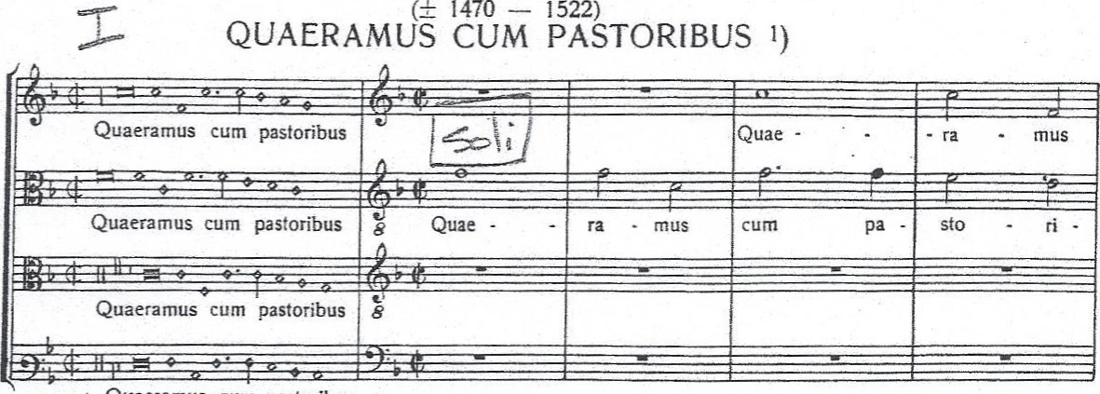
61.
Joannes
Mouton
Quaeramus
cum
pastoribus
Superius
Altus
Tenor
Bassus
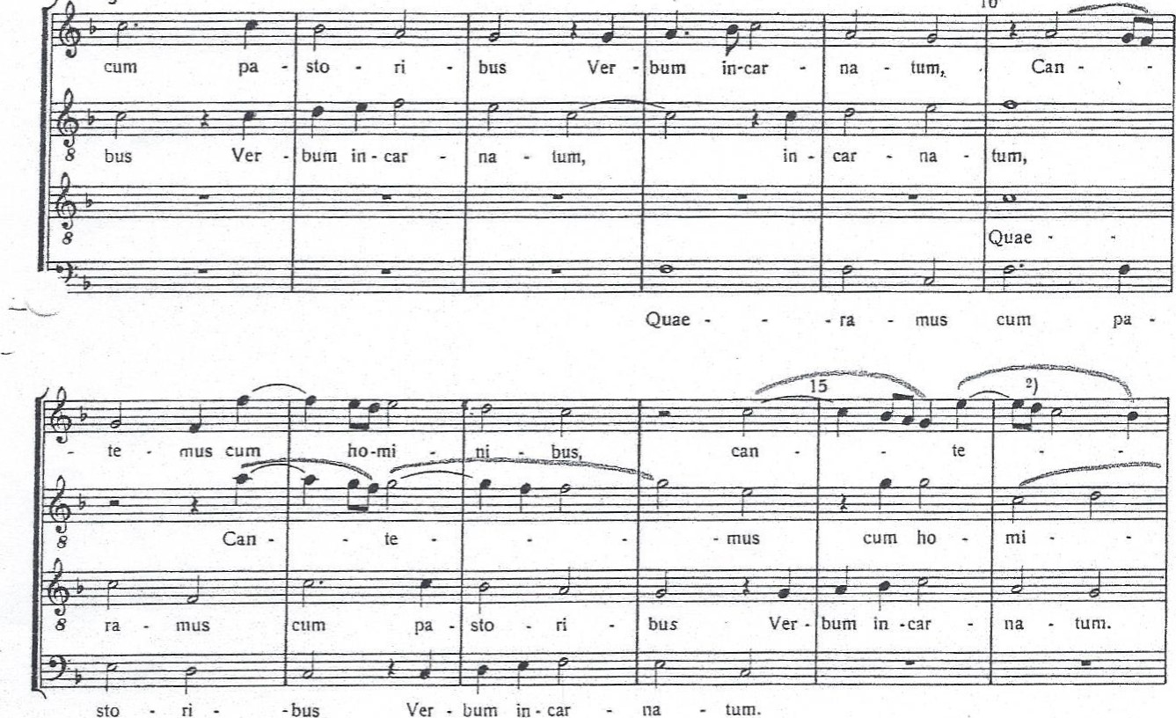
5
10
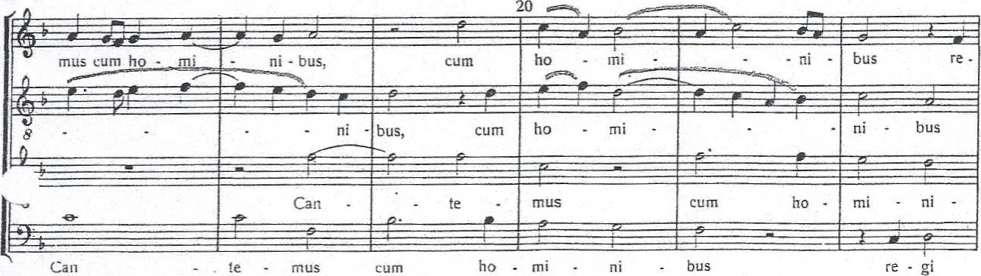
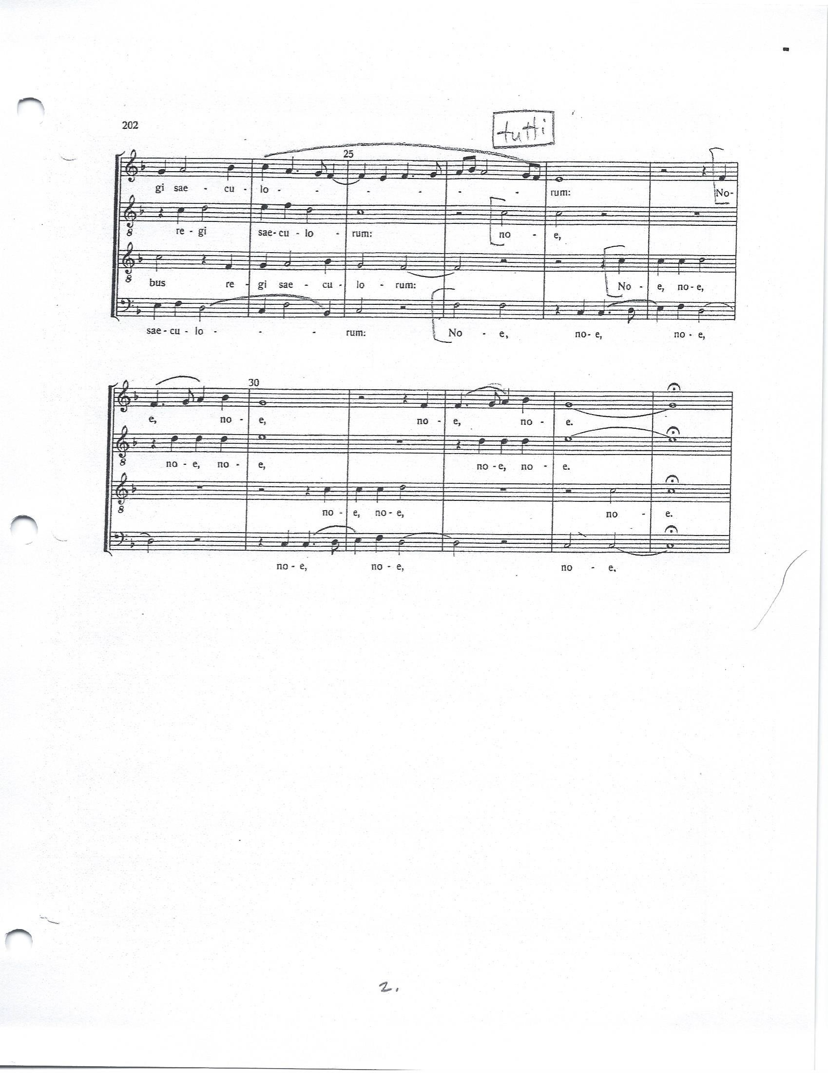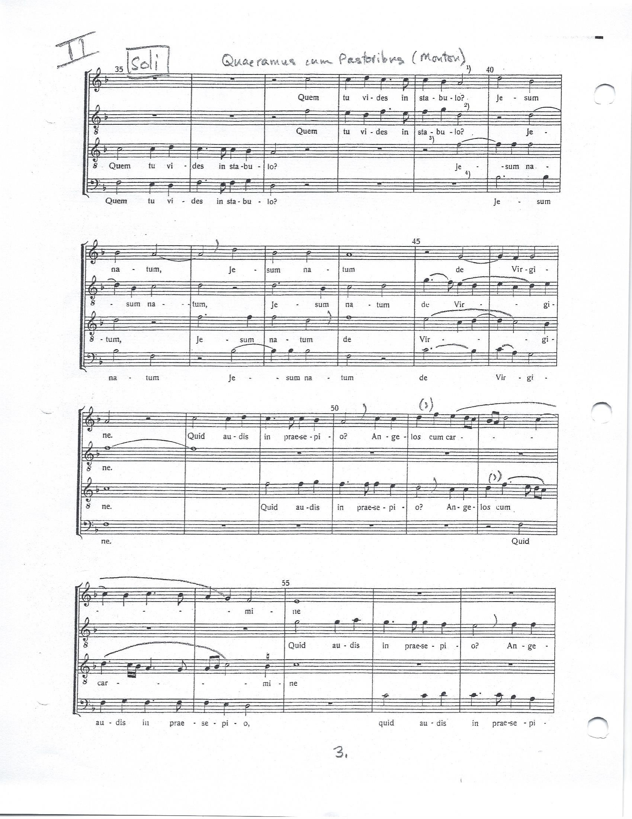
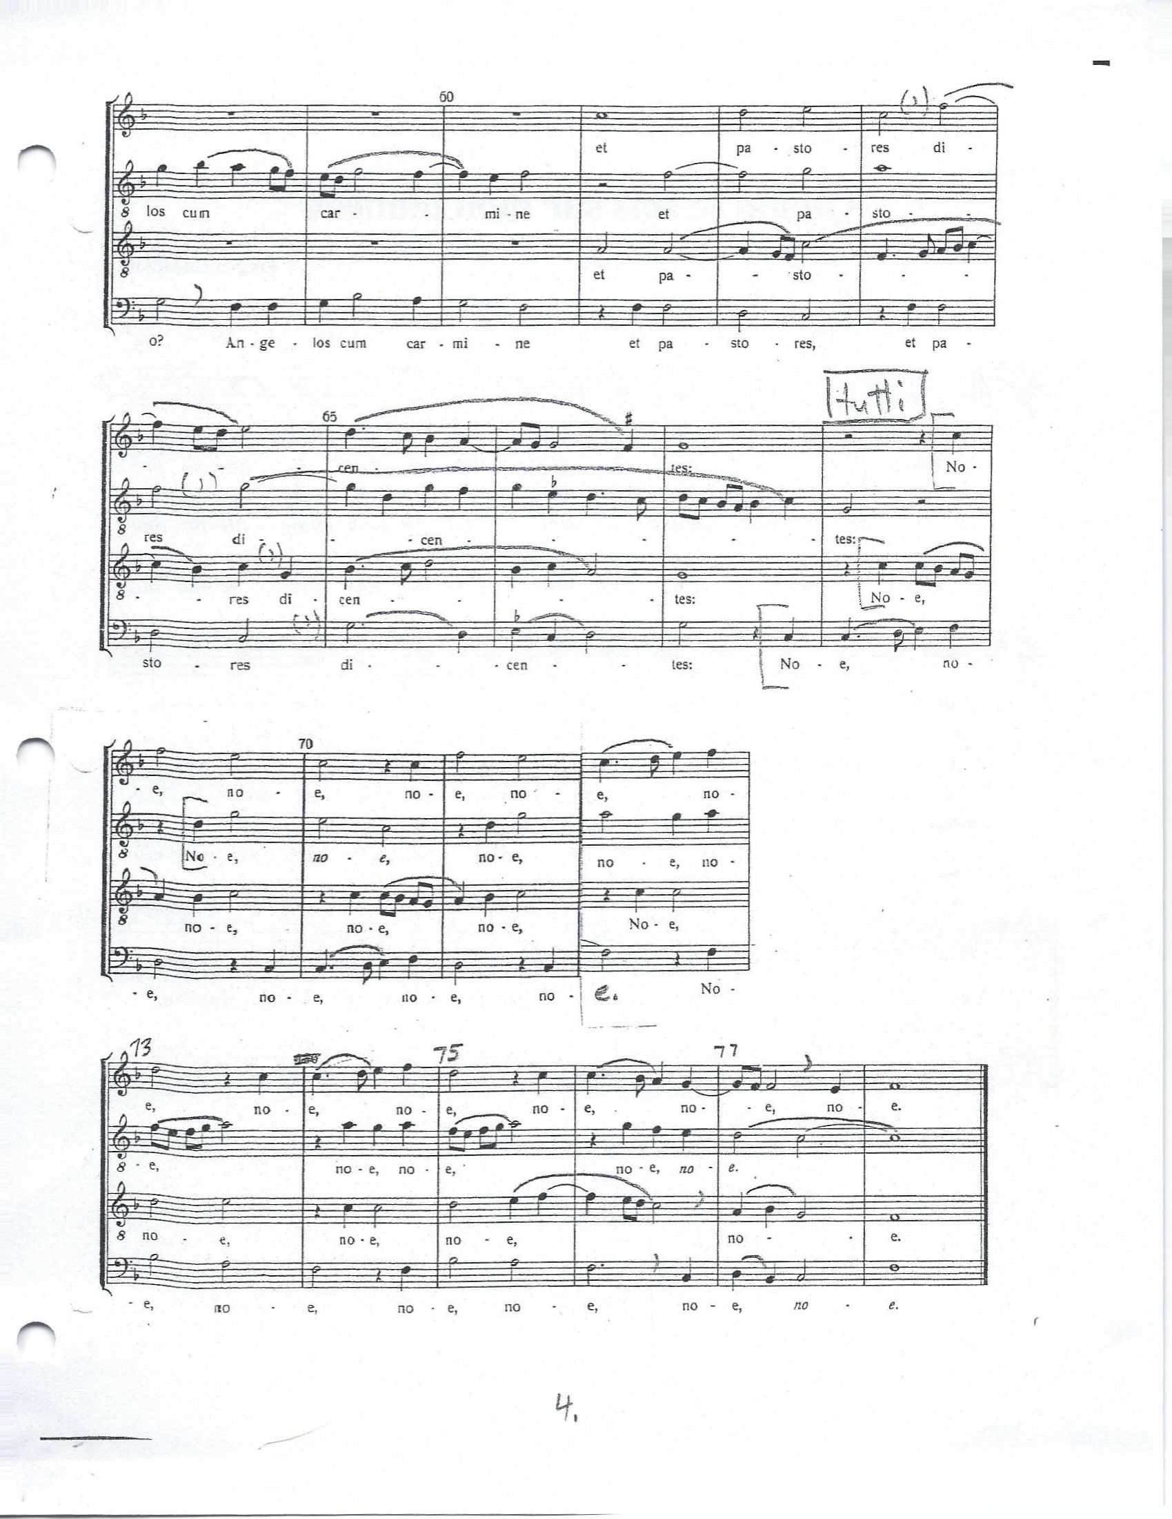

Ti-Jean

Gaston!

PRIEST

Ti-Jean!

TI-JEAN

(All smiles) Yes, Mon Pere?

PRIEST

(sighing) Never mind.

DANCE - Quadrille Verrett, Galope de Quebec

GASTON (approaching priest with woman dancer)
It’s true, father, it’s true. She does dance like the devil! Maybe even better, eh? This woman dances better than the devil himself!

(All Freeze – Devil appears and dances in front of Gaston, as if answering a challenge)

PRIEST
It’s true, Gaston, she dances well, but please let us not speak lightly of the devil, eh?

CHILDREN’S SET
Each stanza is sung first by Nathalie (chorus member) then repeated by the kids

Bonhomme Bonhomme

- Bonhomm’, bonhomm’, sais-tu jouer, bonhomm’, bonhomm’, sais-tu jouer?
- Bonhomm’, bonhomm’, sais-tu jouer, bonhomm’, bonhomm’, sais-tu jouer?
Sais tu jouer de ce violon là, sais tu jouer de ce violon là?
Sais tu jouer de ce violon là, sais tu jouer de ce violon là?

Zing, zing, zing, de ce violon là.
Zing, zing, zing, de ce violon là
Refrain:
Bonhomm’! Bonhomm’!
Tu n’es pas maitr’ dans ta maison, bonhomme,
Quand nous y sommes!

- Bonhomm’, bonhomm’, sais-tu jouer, bonhomm’, bonhomm’, sais-tu jouer?
- . Bonhomm’, bonhomm’, sais-tu jouer, bonhomm’, bonhomm’, sais-tu jouer?
Sais tu jouer de cett’ flûte-lâ, sais tu jouer de cett’ flûte-lâ?
Sais tu jouer de cett’ flûte-lâ, sais tu jouer de cett’ flûte-lâ?
Flûte, flûte, flûte de cett’ flûte-là,
Flûte, flûte, flûte de cett’ flûte-là,
Zing, zing, zing, de ce violon-là.
Zing, zing, zing, de ce violon-là.

Refrain:
Bonhomm’! Bonhomm’!
Tu n’es pas maitr’ dans ta maison, bonhomme,
Quand nous y sommes!

Bonhomm’, bonhomm’, sais-tu jouer, bonhomm’, bonhomm’, sais-tu jouer?
Bonhomm’, bonhomm’, sais-tu jouer, bonhomm’, bonhomm’, sais-tu jouer?
Sais-tu jouer de ce tambour-là, Sais-tu jouer de ce tambour-là?
Sais-tu jouer de ce tambour-là, Sais-tu jouer de ce tambour-là?
Boum, boum, boum, de ce tambour-là,
Boum, boum, boum, de ce tambour-là,
Flûte, flûte, flûte de cett’ flûte-la,
Flûte, flûte, flûte de cett’ flûte-la,
Zing, zing, zing, de ce violon-là.
Zing, zing, zing, de ce violon-là

Refrain:
Bonhomm’! Bonhomm’!
Tu n’es pas maitr’ dans ta maison, bonhomme,
Quand nous y sommes!

4. Bonhomm’, bonhomm’, sais-tu jouer, bonhomm’, bonhomm’, sais-tu jouer?
4. Bonhomm’, bonhomm’, sais-tu jouer, bonhomm’, bonhomm’, sais-tu jouer?
Sais tu jouer de cett’ cornet-là, sais tu jouer de cett’ cornet-là?
Sais tu jouer de cett’ cornet-là, sais tu jouer de cett’ cornet-là?
Taratata, de ce cornet-là,
Taratata, de ce cornet-là,
Boum, boum, boum, de ce tambour-là,
Boum, boum, boum, de ce tambour-là
Flûte, flûte, fûlte de cett’ flûte-la,
Flûte, flûte, fûlte de cett’ flûte-la
Zing, zing, zing, de ce violon-là.
Zing, zing, zing, de ce violon-là.

Refrain:
Bonhomm’! Bonhomm’!
Tu n’es pas maitr’ dans ta maison, bonhomme,
Quand nous y sommes!

Mon canot décorse
1. Mon père n’avait garςon que moi, canot d’écorce qui volera,
I was my father’s only son, canot décorce qui volera.
Dans les chantiers loin il m’envoie,
Canot d’écorce qui vole, qui vole, canot d’écorce qui volera.
Canot d’écorce qui vole, qui vole, canot d’écorce qui volera

2. Dan les chantiers loin il m’envoie, canot d’écorce qui volera
He sent me to the logging camps, canot d’écorce qui volera
Dis-moi la belle tu m’ecrivras,
Canot d’écorce qui vole, qui vole, canot d’écorce qui volera.
Canot d’écorce qui vole, qui vole, canot d’écorce qui volera.

3. Dis moi, la belle tu m’ecrivras, canot d’écorce qui volera
Tell me my love, you’ll write to me, canot d’écorce qui volera
Sont les oiseaux qui m’le dira,
Canot d’écorce qui vole, qui vole, canot d’écorce qui volera
Canot d’écorce qui vole, qui vole, canot d’écorce qui volera

4. Sont les oiseaux qui m’le dira, canot d’écorce qui volera
It was the birds that told me so, canot d’écorce qui volera
Il parlent francais, latin aussi,
Canot d’écorce qui vole, qui vole, canot d’écorce qui volera
Canot d’écorce qui vole, qui vole, canot d’écorce qui volera

CHORUS WOMAN 1

Will you dance the next one with me Father?

PRIEST

Non, merci Helene.

CHORUS WOMAN 2

Will you dance the next one with me father?

PRIEST

Er, Non.

CHORUS WOMAN 3

How about me?

PRIEST

Absolument pas!

WOMEN (surrounding Priest)

Me? Or me? How about me?

PRIEST

Non! Non! Non! Non! Non!

AH! SI MON MOINE VOULAIT DANSER

1. Ah! si mon moine voulait danser!

Ah! si mon moine voulait danser!

Un capuchon je lui donnerais.

Un capuchon je lui donnerais.

Refrain:

Danse, mon moin’, danse!

Tu n’entends pas la danse,

Tu n’entends pas mon moulin. lon la,

Tu n’entends pas mon moulin marcher.

2. If you will come and dance with me,

If you will come and dance with me,

A rosary I will give to thee,

A rosary I will give to thee.

Refrain

Danse, mon moin’, danse!

Tu n’entends pas la danse,

Tu n’entends pas mon moulin. lon la,

Tu n’entends pas mon moulin marcher.

3. Ah! si mon moine voulait danser!

Ah! si mon moine voulait danser!

Un ceinturon je lui donnerais.

Un ceinturon je lui donnerais.

Refrain

Danse, mon moin’, danse!

Tu n’entends pas la danse,

Tu n’entends pas mon moulin. lon la,

Tu n’entends pas mon moulin marcher.

4. If you will come and dance with me,

If you will come and dance with me,

A kiss or two I will give to thee,

A kiss or two I will give to thee.

Refrain

Danse, mon moin’, danse!

Tu n’entends pas la danse,

Tu n’entends pas mon moulin. lon la,

Tu n’entends pas mon moulin marcher.

QUAND JE SUIS SUR MON TONNEAU ( first in French then translated into English)

Quand je suis sur mon tonneau, je chante comme un oiseau

When I’ve got my glass of wine, like a bird I sing so fine.

Les glou-glous de mon flacon sonnent plus fort que mon violon.

As it gurgles down my throat, it drowns out ev’ry other note.

Refrain: sung by chorus (No translation given)
Les buveurs, les voyageurs sont toujours de bonne humeur.

Si la mer changeait en vin, j’en prendrais souvent des bains
If the ocean turned to wine, I’d be swimming all the time.
Je me coulerais au fond, fair’ la guerre à les poissons.
Underneath the waves I’d go, play with fishes down below.

Refrain: sung by chorus
Les buveurs, les voyageurs sont toujours de bonne humeur.

V’la la fin de ma chan-son; il faut vi-der verre et

Fla-con.

That’s the end-ing of my air; raise your glas-ses in the air.

Prends ton verre et moi le mien; ca – ma – rade, vers’-moi du vin!

Drink to me, I’ll drink to you, drink to all our wo – men too!

AUPRÈS DE MA BLONDE

1. Au jardin de mon père les lauriers sont fleuris;

Au jardin de mon père les lauriers sont fleuris,

Tous les oiseåux du monde vont y faire leurs nids.

Refrain: Chorus

Auprès de ma blonde qu’il fait bon, fait bon, fait bon,

Auprès de ma blonde qu’il fait bon dormir.

3. La caill’ la tourterelle, et la jolie perdrix,

The quail, the pretty partridge, the nightingale so gay,

Et la blanche colombe qui chante jour et nuit.

CHORUS AND AUDIENCE - Refrain

Auprès de ma blonde qu’il fait bon, fait bon, fait bon,

Auprès de ma blonde qu’il fait bon dormir.

3. we sing for all the maidens

Who have no man so fine

They do not sing for me, though,

For I’ve a man who’s mine.

CHORUS AND AUDIENCE Refrain

Auprès de ma blonde qu’il fait bon, fait bon, fait bon,

Auprès de ma blonde qu’il fait bon dormir.

(Kids run onto stage holding a handbill)

TI JEAN:

Eh, Albert, Gaston! You know how much the Company is paying for beaver pelts this year?

ALBERT

For beaver? Same as always…..fifty cents? (Ti Jean shakes his head) A dollar? (another shake) More?

TI JEAN

Two dollars!

(other men have heard and come forward)

PIERRE

Two dollars? Two dollars for each pelt?

GASTON

Yes, it’s true.

TI JEAN

Mon dieu….it is worth pursuing, no?

ALBERT

Mon ami, it is worth pursuing…..YES!

GASTON
Bien! Tomorrow morning, Andre and I are starting work on the big canoe at Jacques’ place. If the beaver are breeding like he says, by next Christmas we’ll put new hats on a thousand Englishmen. Who wants to join us and be a voyageur?

MEN
I’ll go.

JEAN- LUC
Count me in.

MEN
But of course! / etc.

CHORUS WOMAN
Voyageurs! You want to go off, leave your family behind. Have big adventure. Poof! I have some advice for all you voyageurs. Now listen well and learn from these lines.

THE WRECK OF THE “JULIE PLANTE!

On wan dark night on Lac St. Pierre,
De win' she blow, blow, blow,
An' de crew of de wood scow "Julie Plante"
Got scar't an' run below
For de win' she blow lak hurricane,
Bimeby she blow some more,
An' de scow bus' up on Lac St. Pierre
Wan arpent from de shore.

De captinne walk on de fronte deck,
An' walk de hin' deck too
He call de crew from up de hole,
He call de cook also.
De cook she 's name was Rosie,
She come from Montreal,
Was chambre maid on lumber barge,
On de Grande Lachine Canal.

De win' she blow from nor' -eas' -wes',--
De sout' win' she blow too,
W'en Rosie cry, "Mon cher captinne,
Mon cher, w'at I shall do ?"
Den de captinne t'row de beeg ankerre,
But still de scow she dreef,
De crew he can't pass on de shore,
Becos' he los' hees skeef.

De night was dark lak wan black cat,
De wave run high an' fas',
W'en de captinne tak' de Rosie girl
An' tie her to de mas'.
Den he also tak' de life preserve,
An' jomp off on de lak',
An' say, "Good-bye, ma Rosie dear,
I go drown for your sak'."

Nex' morning very early
'Bout ha'f-pas' two--t'ree--four—
De captinne--scow--an' de poor Rosie
Was corpses on de shore,
For de win' she blow lak hurricane,
Bimeby she blow some more,
An' de scow bus' up on Lac St. Pierre,
Wan arpent from de shore.

MORAL
Now all good wood scow sailor man
Tak' warning by dat storm
An' go an' marry some nice French girl
An' leev on wan beeg farm.
De win' can blow lak hurricane
An' s'pose she blow some more,
You can't get drown on Lac St. Pierre
So long you stay on shore.

GASTON
Yeah, yeah….stay on the farm and scratch for a living with the chickens. Not for me. I want a better life! Let’s drink to the life of a Voyageur! (other men concur)

RINÇONS-NOUS LA DALE
This repeats 5 times
Rinçons nous la dalle, la dalle,
Rinçons nous la dalle du cou.
La dalle du cou, le cou de la dall’,
La dalle du cou, le cou de la dall’!

(Translation – Lets rinse our throats! The throat of the neck, the neck of the throat, (etc..))

OUTAIOUIS MEDLEY (band, Step dancer turn)

A LA CLAIRE FONTAINE
(During song, voyageurs gather bundles and packs for the journey, consult their map.)
Solo:

1. À la claire fontaine, m’en allant promener,

J’ai trouvé l’eau si belle que je m’y suis baigné.

Refrain:

Il y a longtemps que je t’aime,

Jamais je ne t’oublierai.

CHORUS humming under solo

2. Sous les feuilles d’un chêne, je me suis fait sécher.

Sur la plus haute branche le rossignol chantait.

Refrain

Il y a longtemps que je t’aime,
Jamais je ne t’oublierai.

Jamais je ne t’oublierai.

CHORUS singing

3. Chante, rossignol chante, toi qui as le coeur gai.

Tu as le coeur a rire, moi je l’ai z’à pleurer.

Refrain:

Il y a longtemps que je t’aime,
Jamais je ne t’oublierai.

Jamais je ne t’oublierai.
4. Je voudrais que la ros

e fût encore à planter,

Et que ma douce amie fût encore à m’aimer.

Refrain :

Il y a longtemps que je t’aime,
Jamais je ne t’oublierai.

Jamais je ne t’oublierai.

PRIEST
Of all the spirits, the spirit of adventure is the strongest, and these voyageurs are thirsty for it. Shall we give them our blessing? Bien sur…..they are going to go adventuring no matter what!

KYRIE - Departure of the Voyageurs
Quaeramus cum pastoribus verbum incarnatum,
Cantemus cum hominibus regi saeculorum.
FULL CHORUS
Noe, noe, noe, noe.

THE LORD OF THE DANCE
1. I danced in the morning when the world was begun,
And I danced in the moon and the stars and the sun,
And I came down from heaven and I danced on the earth,
At Bethlehem I had my birth.

BRASS, CHORUS, AUDIENCE
Refrain:
Dance, then, wherever you may be;
I am the Lord of the Dance, said he,
And I’ll lead you all wherever you may be,
And I’ll lead you all in the dance, said he.

2. I danced for the scribe and the pharisee,
But they would not dance and they wouldn’t follow me.
I danced for the fishermen, for James and John—
They came with me and the dance went on.

Refrain:
Dance, then, wherever you may be;
I am the Lord of the Dance, said he,
And I’ll lead you all wherever you may be,
And I’ll lead you all in the dance, said he.

3. I danced for the people and I cured the lame;
The high and mighty said it was a shame.
They whipped and they stripped and they hung me on high,
And they left me there on a cross to die.

Refrain:
Dance, then, wherever you may be;
I am the Lord of the Dance, said he,
And I’ll lead you all wherever you may be,
And I’ll lead you all in the dance, said he.

4. I danced on a Friday when the sky turned black—
It’s hard to dance with the devil on your back.
They buried my body and they thought I’d gone,
But I am the dance, and I still go on.

Refrain:
Dance, then, wherever you may be;
I am the Lord of the Dance, said he,
And I’ll lead you all wherever you may be,
And I’ll lead you all in the dance, said he.

5. They cut me down and I leapt up high;
I am the life that’ll never, never die;
I’ll live in you if you’ll live in me—
I am the Lord of the Dance, said he.

Refrain :
Dance, then, wherever you may be;
I am the Lord of the Dance, said he,
And I’ll lead you all wherever you may be,
And I’ll lead you all in the dance, said he.

INTERMISSION

SECOND PART

A trappers camp deep in the wilderness. A campfire. Snowshoes. Parkas.

HURON CAROL

1. ‘Twas in the moon of wintertime when all the birds had fled,
That mighty Gitchi Manitou sent angel choirs instead.
Before their light the stars grew dim
And wondering hunters heard the hymn:
Refrain:
Jesus your king is born, Jesus is born;
In excelsis gloria!

2. Within a lodge of broken bark the tender babe was found;
A ragged robe of rabbit skin enwrapped his beauty round.
But as the hunter braves drew nigh
The angel song rang loud and high:
Refrain (ALL)

3. The earliest moon of wintertime is not so round and fair
As was the ring of glory on the helpless infant there.
The chiefs from far before him knelt
With gifts of fox and beaver pelt.
Refrain (ALL)

4. O children of the forest free, O seed of Manitou,
The holy child of earth and heaven is born today for you.
Come kneel before the radiant boy who brings you beauty, peace and joy.
Refrain

PRIEST:

It is New Year’s Eve and deep in the wilderness the voyageurs are huddled around their fire dreaming of the parties and

the good times at home in Trois Rivieres.

ALBERT

Another New Year! I thought you said we’d be rich men by now, and back home drinking toasts and dancing. Dancing! The only dancing around here is Ti-Jean trying to keep his feet warm.

GASTON

Merde!

TI-JEAN

If we could only be back in Trois Rivières. I can see it now, the food, the drink, the dancing – Isabelle. Marie.

PIERRE

Helene…..

ALBERT

Catherine……

ANDRE

Carole…..

ALBERT

Francoise…..

GASTON

Ah, Francoise………La belle Francoise!

ALL

Francoise!

LA BELLE FRANCOISE (second line is translation)

sung by Steven, Gabe and Greg

1. C’est la belle Françoise, lon gai,
Voilà the fair Françoise
Qui veut s’y marier, ma luron, lurette,
She would wed if she may, maluron, luré.

2. Son amant va la voire, lon gai,
Her lover came to see her.
Bien tard, après souper, ma luron, lurette,
After supper is done, ma luron, luré.

3. Adieu, belle Françoise, lon gai,
Adieu, my dear Françoise.
Je vous épouserai, ma luron, lurette,
I will marry you soon, ma luron, luré.

GASTON

Francoise. Merde! For a dance with that coquette Francoise, I’d sell my soul to the devil!

LX The Devil appears UL, all freeze except Gaston

PRIEST:

Now this is an offer that a self-respecting devil cannot refuse. Gaston is summoned for a private interview.

(The Devil beckons Gaston. )

Drawing him close, the Devil breathes three words – LA CHASSE GALERIE. Here is the deal – the Devil will loan the voyageurs his flying canoe which will whisk them back to Trois Rivières in time for this evening’s New Year’s Party. In return they must promise not to SWEAR,

bell,

not to drink WINE,

bell,

and to be back before MIDNIGHT,

bell.

Of course, if these three conditions are not met…their souls are FORFEIT.

(Devil snaps his fingers and the voyageurs unfreeze)

GASTON (Returning to his companions)

Voila! Mes compagnons! Tonight we’re going to a party!

TI-JEAN

What are you talking about? (Indicating the Devil) And where did he come from?

GASTON

Trois Rivières! He’s a friend of mine from Trois Rivières. Tonight we’re going home!

ALBERT

Trois Rivières! Tonight! You’re crazy as a coot. The rivers are frozen. We’re six months travel away….

GASTON

You don’t understand. My friend here is offering us the Chasse Galerie. We’ll fly above the clouds and be home in time for the first dance. Here’s the deal…..

(They huddle as he explains. GASTON separates from group to C

They all look at the Devil. They look at their shoes. Look at Gaston. Look at shoes. Look at each other.)

Come on!

PRIEST:
Adventure had brought them this far. Why not take the chance? They were voyageurs after all.

(They shrug their shoulders. The band begins foot tapping rhythm.

A canoe is carried onto stage. The men climb aboard and begin to paddle.)

LA CHASSE-GALERIE CANOE SONGS SEQUENCE

AU BORD DE LA FONTAINE

Solo 1. Au bord de la fontaine, la belle m’a dondaine,

Chorus. Au bord de la fontaine, la belle m’a dondaine,

Solo 1. Au joli mois de mai la belle m’a dondé,

Solo 1&2. . Au joli mois de mai la belle m’a dondé,

Chorus. Au joli mois de mai la belle m’a dondé.

Au joli mois de mai la belle m’a dondé.

Solo 1. Sur la branche d’un chêne la belle m’a dondaine.

Chorus. Sur la branche d’un chêne la belle m’a dondaine.

Solo 1&2 Beau rossignol chantait la belle m’a la la la,

Chorus Beau rossignol chantait la belle m’a dondé.

Beau rossignol chantait la belle m’a dondé

Music vamp continues under action

PRIEST:

Higher than the tops of the trees, higher than the mountains, higher than the clouds they climbed, and speeding through the air with the snow freezing on their faces they set course for their hometown.

B) ENVOYONS D’AVANT NOS GENS!
1. Quand on pâre des chanquiers, mes chers amis tous le coeur gai,
Pour aller voir tous nos parents, mes chers amis, le coeur content.

Refrain: Chorus
Envoyons d’l’avant nos gens! Envoyons d’l’avant!
Envoyons d’l’avant nos gens! Envoyons d’l’avant!

2. Pour aller voir tous nos parents, mes chers amis le coeur content.
Mais qu’on arrive en Canada, ill va falloir y mouilier ça.

Refrain: Chorus
Envoyons d’l’avant nos gens! Envoyons d’l’avant!
Envoyons d’l’avant nos gens! Envoyons d’l’avant!

- V’LA L’BON VENT

Refrain: Chorus
V’la l’bon vent, v’la l’joli vent, v’la l’ bon vent, ma mie m’appelle,
V’la l’bon vent, v’la l’joli vent, v’la l’ bon vent, ma mie m’attend.

1.Derrière chez nous y’a t’un étang,
Derrière chez nous y’a t’un étang,
Trois beaux canards s’en vont baignant.

Refrain: Chorus
V’la l’bon vent, v’la l’joli vent, v’la l’ bon vent, ma mie m’appelle,
V’la l’bon vent, v’la l’joli vent, v’la l’ bon vent, ma mie m’attend.

2. Trois beaux canards s’en vont baignant.
Trois beaux canards s’en vont baignant.
Le fils du roi s’en va chassant.

Refrain: Chorus
V’la l’bon vent, v’la l’joli vent, v’la l’ bon vent, ma mie m’appelle,
V’la l’bon vent, v’la l’joli vent, v’la l’ bon vent, ma mie m’attend.

D) ENVOYONS D’AVANT NOS GENS
3. Mais qu’on arrive en Canada, il va falloir y mouiller ça,
Ah! mais qu’ça soye tout mouillé, vous allez voir qu’ça va marcher.

Refrain:
Envoyons d’l’avant nos gens! Envoyons d’l’avant!
Envoyons d’l’avant nos gens! Envoyons d’l’avant!

4. Ah! mais qu’ça soye tout mouillé, vous allez voir qu’ça va marcher,
Mais qu’nos amis nour voyent arriver, ils vont s’mettre à rire, à chanter.

Refrain:
Envoyons d’l’avant nos gens! Envoyons d’l’avant!
Envoyons d’l’avant nos gens! Envoyons d’l’avant!

PRIEST:
In no time at all the church spires of Trois Rivières were below them, and after a long slow descent, the canoe deposited them right next to the village hall.

F) V’LA LE BON VENT

Refrain:
V’la l’bon vent, v’la l’joli vent, v’la l’ bon vent, ma mie m’appelle,
V’la l’bon vent, v’la l’joli vent, v’la l’ bon vent, ma mie m’attend.

1.Le fils du roi s’en vont baignant
Le fils du roi s’en vont baignant
Avec son grand fusil d’argent..

Refrain (ALL)
V’la l’bon vent, v’la l’joli vent, v’la l’ bon vent, ma mie m’appelle,
V’la l’bon vent, v’la l’joli vent, v’la l’ bon vent, ma mie m’attend.

2. Avec son grand fusil d’argent
Avec son grand fusil d’argent
Visa le noir, tua le blanc.

Refrain:
V’la l’bon vent, v’la l’joli vent, v’la l’ bon vent, ma mie m’appelle,
V’la l’bon vent, v’la l’joli vent, v’la l’ bon vent, ma mie m’attend.
V’la l’bon vent, v’la l’joli vent, v’la l’ bon vent, ma mie m’appelle,
V’la l’bon vent, v’la l’joli vent, v’la l’ bon vent, ma mie m’attend.

End of canoe sequence

Woman Laughs

ALBERT

That’s Sabine, I can tell her by her laugh.

GASTON

Mon Dieu! That’s Benoit with my Marie!

A howl offstage

PIERRE

You swore!

GASTON

I didn’t.

PIERRE

“Mon Dieu!?”

ANDRE
Oue, mon ami, “Mon Dieu” is swearing!

Another woman laughs

TI-JEAN

Baptème! That’s Francoise! I can’t wait! Let’s get up there!

The Voyageurs enter and are greeted with surprise and joy

PRIEST:

Oh, the amazement on the faces of the townsfolk! The tears of joy that were shed as lovers were reunited! The slaps on the back as old friends embraced. And then the toasts! How can you not drink wine when there are toasts? Besides, there was no sign of their dark companion.

BAND SET

LE BASTRINGUE - circle dance

PRIEST

Let us give thanks for the safe return of the voyageurs.

GASTON

I’ll drink to that!

He does. A howl is heard offstage.

ALBERT

The wolves are out tonight.

TI-JEAN

Attention! Watch out for your lambs, shepherds!

PRIEST

Attention! Watch out for your soul Ti-Jean!

(The Priest shepherds the Children into place)

PRIEST

Mies’ Enfant

CHILDREN’S SET:

IL ÉTAIT UNE BERGÈRE

1. Il était un’ bergère,

Et ron, ron, ron, petit patapon;

Il était un’ bergère

Qui gardait ses moutons, ron, ron,

Qui gardait ses moutons.

2. Elle fit un fromage,

Et ron, ron, ron, petit patapon;

Elle fit un fromage

Du lait de ses moutons, ron, ron,

Du lait de ses moutons.

3. Le chat qui la regarde,

Et ron, ron, ron, petit patapon;

Le chat qui la regarde

D’un petit air fripon, ron, ron,

D’un petit air fripon.

4. Si tu y mets la patte,

Et ron, ron, ron, petit patapon;

Si tu y mets la patte

Tu auras du baton, ron, ron,

Tu auras du baton.

5. Il n’y mit pas la patte,

Et ron, ron, ron, petit patapon;

Il n’y mit pas la patte

Il y mit le menton, ron, ron,

Il y mit le menton.

6. La bergère en colère,

Et ron, ron, ron, petit patapon;

La bergère en colère

Tu a son p’tit chaton, ron, ron,

Tu a son p’tit chaton.

D’OU VIENS-TU, BERGÈRE?

1. D’où viens tu, bergère, d’où viens tu?
I come from the stable, where, this very night,
I, a shepherd maiden, saw a wondrous sight,
Saw a wondrous sight.

2. Qu’as tu vu, bergère, qu’as tu vu?
There within a manger a little child I saw,
Lying, softly sleeping, on a bed of straw,
On a bed of straw.

3. Rien de plus, bergère, rien de plus?
There I saw the mother her sweet baby hold,
And the father, Joseph, trembling in the cold,
Trembling in the cold.

4. Rien de plus, bergère, rien de plus?
I saw ass and oxen, kneeling meek and mild,
With their gentle breathing warm the holy child,
Warm the holy child.

5. Rien de plus, bergère, rien de plus?
There were three bright angels come down from the sky,
Singing forth sweet praises to our God on high,
To our God on high.

CHILD
Mon Pere? My father says he came home in a flying canoe that belongs to the Devil. But the devil doesn’t really exist, does he?

PRIEST
Many would agree with you, my child, but the world is full of stories about the Dark One. Rahoul, I think I recall that you have a story about the Devil and his canoe, yes?

RAHOUL
I do indeed. It’s the story of Lazy Jean and the Loup Garou!
There once was a man called Jean Dubois but everybody called him “Lazy Jean,” because he never was seen to do a lick of work. He just sat on his porch all day, smoking his pipe and drinking his beer, and yet his crops were always the best in the neighborhood and his barn and fences all strong and well tended.

There were also reports of strange, unearthly noises coming from his place late at night, when good people were asleep. So one night his neighbor, Alphonse, decided to hide and see if he could figure out the source of those noises. He crawled under a bush and waited. And waited. And when he had almost fallen asleep he suddenly heard a loud, roaring sound overheard. Looking up, he saw a flying canoe! And if that wasn’t incredible enough, the next thing he knew the canoe landed and the Devil jumped out!

Alphonse crawled farther into the bush, nearly too afraid to breathe. Then he heard the Devil command, “Get out and get to work!” And out of the canoe climbed six creatures with shaggy coats who walked upright like men. Alphonse knew immediately what they were----werewolves, called loup garou----men who had so neglected their religious duties that they fell under the spell of the Devil and were turned into such creatures. Incredulous, he watched as they did all the chores of the farm before getting back into the canoe and flying away.

Alphonse went directly to the local priest to tell him what he’d seen, and the priest devised a clever plan to foil the Devil and free the loup garou. He gave Alphonse a bottle of holy water and told him to scatter it on the ground where the canoe landed. So the next night Alphonse snuck back onto Jean’s farm and did as he’d been told. Then he hid again and waited. Soon the canoe appeared and landed, but when the Devil hopped out and his feet touched the holy water he started shrieking and leaping about in pain which so frightened the poor loup garou that they jumped out of the canoe just as the Devil jumped back in and took to the sky in a blast of fire.

The men of the parish collected the werewolves and brought them to the priest who pricked each one with a knife, so some blood ran out, which they didn’t mind because it’s the only way to turn a loup garou back into a man! One by one they fell to their knees and begged the priest to forgive them for neglecting their religious duties. He did, of course, and they never were absent from church again.

CHILD
Was that a true story?

PRIEST
What does it matter, it’s a good story, yes? Never make a deal with the Devil.

CHILD
I won’t!!

DONA NOBIS PACEM
Dona nobis pacem, pacem, dona nobis pacem

VIVE LA COMPAGNIE
Let every good fellow now join in our song, Vi – ve la compnie!
Success to each other and pass it along, Vi -ve la companie.

Refrain:
Vi -ve la, vi – ve la, vi – ve l’a -mour!
Vi – ve la, vi – ve la, vi – ve l’a – mour! Vi – ve l’a – mour!
Vi – ve l’a – mour! Vi – ve la companie!

And also you maidens come join in our song Vi – ve la companie!
I lift your gay yules and help it along Vi – ve la compnie,

Refrain:
Vi -ve la, vi – ve la, vi – ve l’a -mour!
Vi – ve la, vi – ve la, vi – ve l’a – mour! Vi – ve l’a – mour!
Vi – ve l’a – mour! Vi – ve la companie!

A friend on the left and a friend on the right, Vi – ve la companie!
A song of a good friend ship we’re sing – ing tonight, Vi – ve la compnie!

Refrain:
Vi -ve la, vi – ve la, vi – ve l’a -mour!
Vi – ve la, vi – ve la, vi – ve l’a – mour! Vi – ve l’a – mour!
Vi – ve l’a – mour! Vi – ve la companie!

Repeat:
Vi -ve la, vi – ve la, vi – ve l’a -mour!
Vi – ve la, vi – ve la, vi – ve l’a – mour! Vi – ve l’a – mour!
Vi – ve l’a – mour! Vi – ve la companie!

LA GUIGNOLÉE
(first and second stanzas are the same)

- Bonjour, le maître et la maîtresse et tout le monde de la maison!
- Bonjour, le maître et la maîtresse et tout le monde de la maison!
- Pour le dernier jour de l’année, la Ignolée vous nous devez.
- Pour le dernier jour de l’année, la Ignolée vous nous devez.
- Si vous voulez rien nous donner, dites-nous lée!
- Si vous voulez rien nous donner, dites-nous lée!

Master and mistress of this house and everyone here, good day to you!
Master and mistress of this house and everyone here, good day to you!
This is the last day of the old year, we come to celebrate the new.
This is the last day of the old year, we come to celebrate the new.
If you will give us food and drink you’ll have our their blessing too!
If you will give us food and drink you’ll have our their blessing too!

Master and mistress of this house and everyone here, good day to you!
Master and mistress of this house and everyone here, good day to you!
This is the last day of the year, and now you must give the guignolée.
If you refuse to give them something then they’ll do their play!

GASTON
Oh, no, mesa mis, we are not ready!

ALBERT
We could not rehearse when we were out in the woods! I’m afraid there will be no Mummers Play this year.

PRIEST
Oh you voyageurs, do not trouble yourselves. Do you not have faith in your Women?
They took care of everything while you were gone.. including the play!
Now, get out of the way they are going to be right here.

MUMMERS PLAY - TI-JEAN AND THE LOUP GAROU

ROOM
Attention!
Room, room, messieurs dames,
Make room to see our play
We bring to you both large and small
The New Year Guignolée

TI JEAN

In come I Petit-Jean-Jacques
Avec ma famille on my back
Ma famille est large and I am small
I’ve brought my broom to nettoyer the hall.
Poutine! Red wine! Strong cheese!
What in the world is better than these?

ALL

Rien! Nothing!

ROOM

Step in Père Noel!

PÈRE NOEL

Voici Père Noel! Welcome or welcome not!
J’espère that Père Noel will jamais be forgot.

ALL

Jamais! Jamais!

PERE NOEL

Noel is a jolly fête that comes but once a year
And when it comes it brings beaucoup de cheer
Strong cheese! Red wine! Poutine!
Better than Ti-Jean and I, who likes Québec cuisine?

ALL

Personne!

Offstage howling

ROOM

A Werewolf you shall see
A Loup Garou for to flee
Allez, allez thou Werewolf wild
And frighten every man and child

LOUP GAROU

Stand on tête stand on feet
I need meat for to eat
Je suis le Loup Garou, here are my jaws
I am the Werewolf, here are my claws
If I ever get to meet Ti-Jean
I’ll eat him up like a bon-bon

PERE NOEL
Step forth Ti-Jean thou champion

TI-JEAN
Me voici Petit-Jean!
Just as I came before
I’ll lay this scrawny wolf
Upon the kitchen floor.

LOUP GAROU
Who calls so méchant and so loud
With fighting words and angry tones
Avec my teeth and mauvais jaws
I’ll tear ze flesh from off his bones.

TI-JEAN
What you, Monsieur?

LOUP GAROU
Mais oui, Monsieur

TI-JEAN
I’d like to see you try, Monsieur.
Squirrel!

LOUP GAROU
Wait, there is no squirrel…
They fight. TI-JEAN slays the wolf.

PERE NOEL
O horrible , O terrible
Look what you have done.
You have killed the Loup Garou
Who was my only son.
Is there a doctor to be found
To cure this deep and deadly wound

ALL
Doctor! Médecin! Dentiste! PHD! DVD!

DOCTOR
Here I am Doctor Malgré Lui
Avec my coattails down to my knee
I do the medicine from France
Which makes the dead get up and dance.

PERE NOEL
How came you to be a doctor?

DOCTOR
By my travels.

TI-JEAN
Where have you traveled?

DOCTOR
Italy, Spittaly, Old Québec,
Up your nose and round your neck.

ROOM
Can you cure a werewolf who’s been dead five minutes?

DOCTOR
If he’s been dead five years I can cure him.
Looking in his book
Werewolf, Werewolf, now let’s see,
Here it is - “Lycanthropy”
To separate man from the beast
I shall need a pound of yeast
A bunch of garlic picked in Wales
And three albino mouse’s tails,
The juice of a mosquito’s spleen
Stirred into some nice warm poutine

He mixes the ingredients together and drinks the lot

DOCTOR
That’s better.
Now first we make a good inspection.
And then we make a big injection
Come back for your second in 4 weeks.
And now prepare to see a flood
Of nasty wicked werewolf’s blood
(Doctor gives potion to Loup Garou then attempts to stab with scissors and is stopped)
That will be 75 francs,…. 100 francs,… 50 francs?

TI-JEAN
Wait a minute, this is Canada we don’t have to pay a penny!
Still Dead

ROOM
What do we do?!

PERE NOEL
Do not despair

LOUP GAROU
Bon Jour mes Gentlemen
A sleeping I have been
And I’ve had such a sleep
As the like was never seen

But now I am awake
Alive unto this day
We hope you have enjoyed
Our little Guignolée

ROOM
Our play is done

PERE NOEL
We stay no more

TI-JEAN
We hope you enjoyed the show

ALL
We wish you

DOCTOR
A Happy Brite New Year!

VIVE LA COMPAGNIE – Reprise

1. Now we have given you our guignolée,
Vive la compagni’!
Now is the time for you people to pay,
Vive la compagni’!

Refrain:
Vive, vive, vive l’amour!
Vive, vive, vive la vi’,
Vive la vi’, vive l’amour!
Vive la compagni’!

2. A glass of red wine and a bottle of beer,
Vive la compagni’!
We wish you all joy and a happy new year
Vive la compagni’!

Refrain

Midnight tolls on the church bell. Thunder. LX. The Devil appears. All freeze.

PRIEST:
The Devil of course, is in the details. Swearing, drinking and tardiness. And the voyageurs, who had paid little attention to the time or the fine print, were being summoned by their creditor.

The Devil beckons the voyageurs who cross to him.

PRIEST (To the Devil) Stop! I will gamble with you for these souls. I will bet that you cannot dance a jig as fast as a Québecois. (Devil laughs. Brass?) No need to be rude. If you are so great a dancer, prove it before all these good people. Choose any Québecois– they can all dance better than you.

(Aside to audience) Now everyone knows that the Devil can never turn down a good wager. Especially with a priest. And he did pride himself on being a fine dancer. So…

(Dance contest)

Let the public decide who is the winner. Applause please for contestant number one – (Audience applaud)s And for contestant number two – (Audience applauds)

Begone demon whence you came!

The Devil exits with smoke? Flames? Sound?

GASTON
Mon Dieu! That was close.

PRIEST
Gaston! I told you that your big mouth would get you into trouble one day. From now on I want to see all of you in the choir every Sunday. And don’t you ever be late!

VOYAGEURS
Oui, mon pere.

PRIEST
(to Ti-Jean) And don’t you ever be late!

TI-JEAN
Non, non, mon pere!

The village is assembled DC

PRIEST:
The voyageurs took the priest at his word. Ti-Jean was never late for anything again, Albert combed his hair every day, and Gaston developed a taste for root beer and joined the Lacondaire. And every Sunday evening when the choir practiced in the big church on top of the hill, their voices could be heard ringing out over the snowy town.

QUAERAMUS CUM PASTORIBUS

Quem tu vides in stabulo?
Jesum natum de Virgine.
Quid audis in praesepio?
Angelos cum carmine et pastores dicentes:
Noe, noe, noe, noe.

PRIEST
(approaching Rahoul, who is busy writing) So, M’seur Le Raconteur, what are you so busy writing?

RAHOUL
What else but the story that happened here with the voyageurs and the devil and his flying canoe? They will love it out west! Especially the happy ending, thanks to you, Father.

CHORUS
(Phrases of agreement)

RAHOUL
And now I must be on my way. Until next year! (He exits)

SALVE PUERULE
Sal- ve pu – e -ru-le, sal-ve_te nel – lu-le-, o na – te par – vu-le quam bo – mus
Es, o na – te par – vu-le quam bo – nus es Tu coe – lum de - se -ris, tum un-do
Nas – ce-ris, no -bis te’ut mi – se-ris as-si – mi-les, no -bis te’ut mi - se-ris as – si – mi-les.

THE SHORTEST DAY

So the shortest day came,
and the year died,
And everywhere down the centuries
of the snow-white world
Came people singing, dancing,
To drive the dark away.
They lighted candles in the winter trees;
they hung their homes with evergreen;
They burned beseeching fires all night long
to keep the year alive.
And when the new year’s sunshine blazed awake
They shouted, revelling.
Through all the frosty ages you can year them
Echoing, behind us - listen!
All the long echoes sing the same delight,
This shortest day,
As promise wakens in the sleeping land:
They carol, feast, give thanks,
And dearly love their friends,
and hope for peace.
And so do we, here, now,
This year and every year.
Welcome Yule!

SUSSEX MUMMERS CAROL

1. God bless the master of this house with happiness beside;
Where e’er his body rides or walks, his God must be his guide,
His God must be his guide.

2. God bless the mistress of this house with gold chain ‘round her breast;
Where e’er her body sleeps or wakes, Lord send her soul to rest,
Lord send her soul to rest.

3. God bless your house, your children too, your cattle and your store;
The Lord increase you day by day, and send you more and more,
And send you more and more.

Curtain Calls
BRASS and BAND

11/8/04
Quand je suis sur mon tonneau
French Canadian
- Quand je suis sur mon ton - neau, je chan -te comme un oi- seau. When I've got my glass of wine, like a bird 1 sing so fine.
- Si la merchange - ait en vin, j'en prendrais sou - vent des bains. If the o - cean turned to wine, I'd be swim- ming all the time.
- V'là la fin de ma chan - son; il faut vi - der verre et fla - con.
Thars the end - ing ofraise your glas - ses in the air. 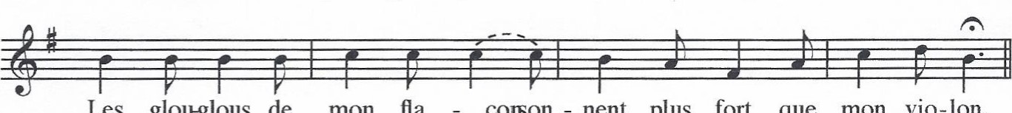
Les
glou-glous
de
mon
fla

corson - nent plus fort que mon vio-lon.

